Hello

I attached 5 screen shots, for the following operation

|  |  |
| --- | --- |
| Zoom in |  |
| Drag up |  |
| Drag down |  |
| Drag right |  |
| Drag left |  |

In each case the expected image is been cropped in some way. In the following screen shots I marked the “cropped” areas that supposed to display a part of the image in red borders. Those areas do not display the image but they should.

Zoom in

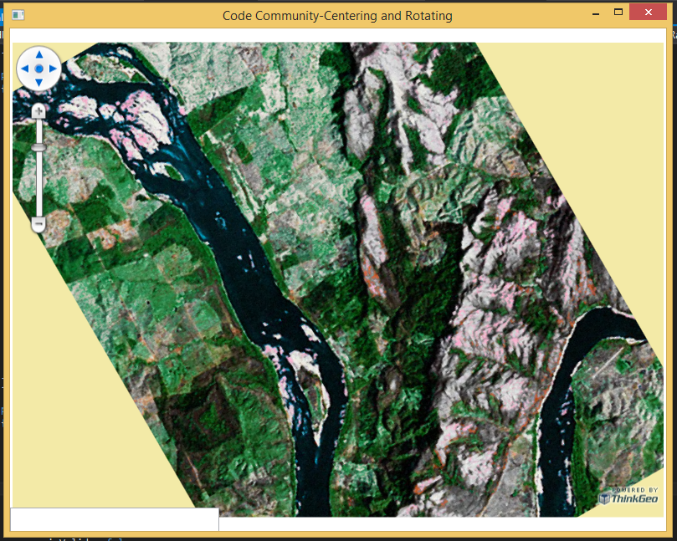

Drag right

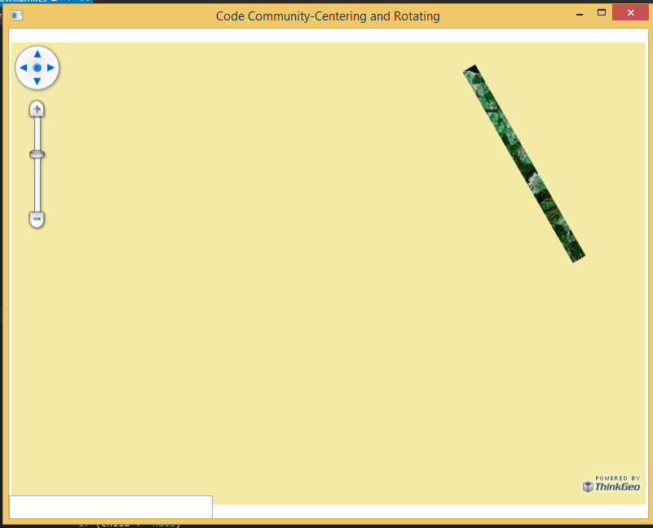

Drag left

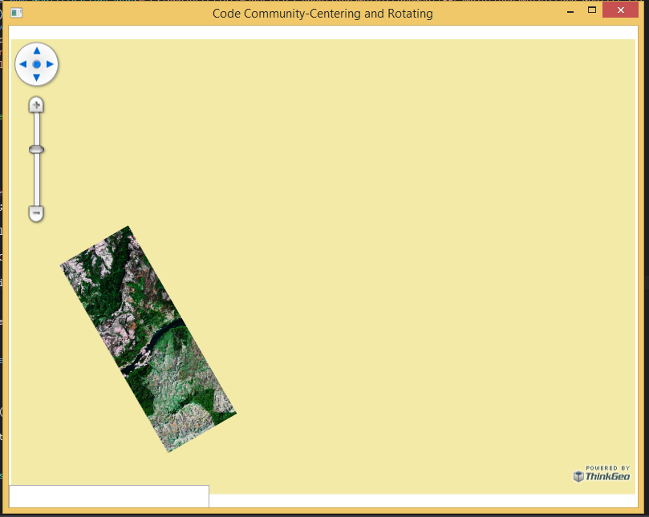

Drag down

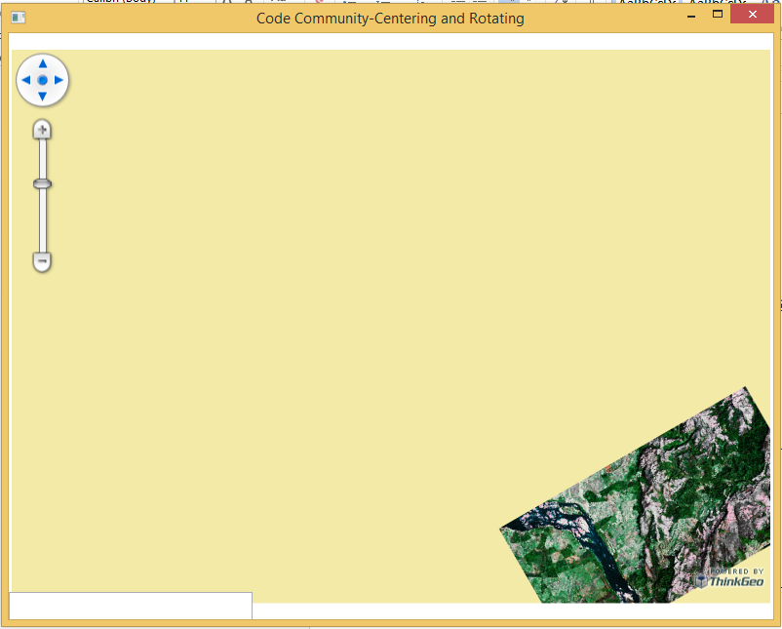

Drag top

