# ThinkGeo WPF Desktop Edition WpfMap control issues

Our map after initialization with no rotation applied using 5.0 assemblies. 3 different layers used.



Our map after a 10 degree angle is applied. Notice the entire map wasn’t rotated; instead it appears that some tiles were rotated differently.

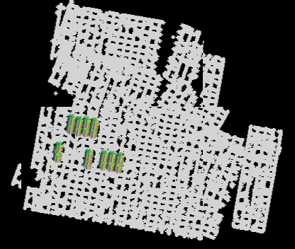

Our map after attempting to zoom in by using the mouse wheel. Notice that the tiles appear to have different rotations applied to each.

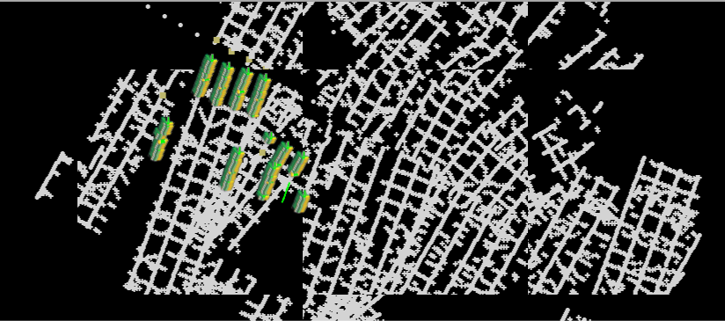

Our map after dragging and dropping the map. Notice that the layer with the green blobs has rotated again but the rest stayed the same.

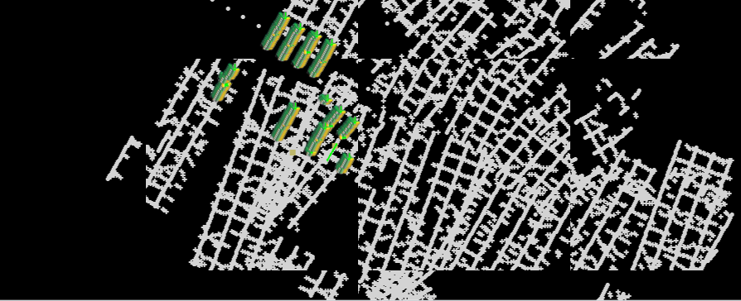

Another zoom-in attempt…things are getting worse!

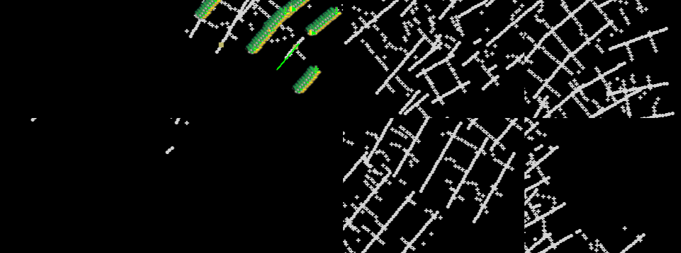

Zoomed back out two times to get back to original zoom level:

