The way our application works is – it displays user’s gps information on the map as stops, if the user is stationary etc. Each of this is an overlay. If the overlays are turned off then no pink tiles. Below screenshot is with the overlays – stops, route information etc.
Pink tile issue -
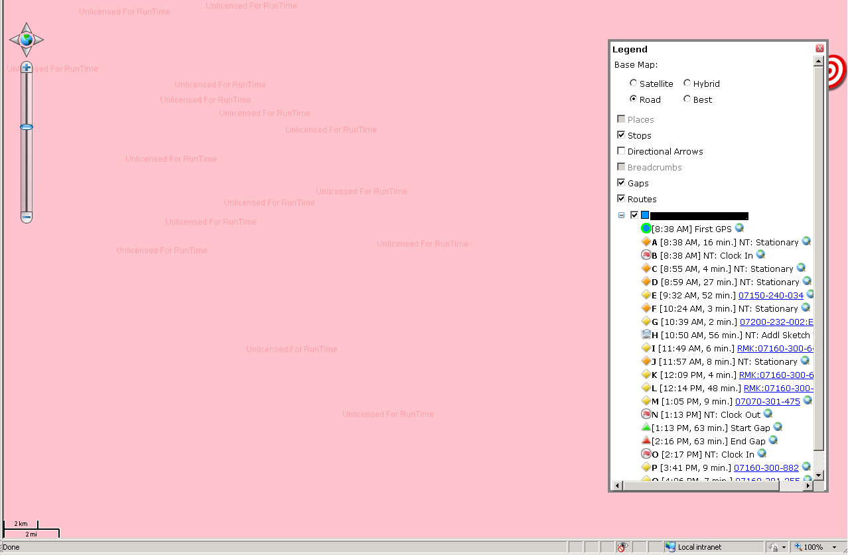

With Overlays turned off the map layer displays fine–
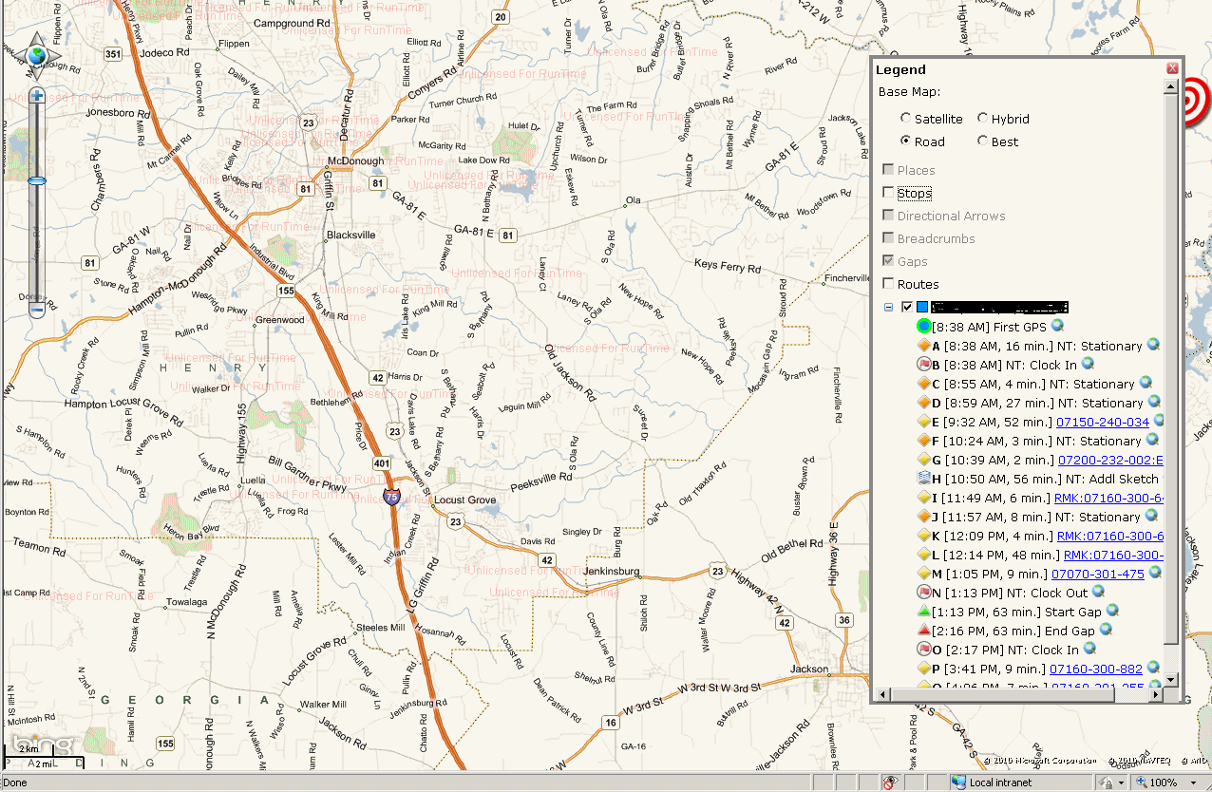

Using Fiddler to check on the Server requests and response –

The request that you see with 0 in the 5th column are the failed requests for the overlays. The most astonishing part is that some requests are successful like the one highlighted. It is one of the over lay as well.

Using fiddler to check the RawXML for failed request– 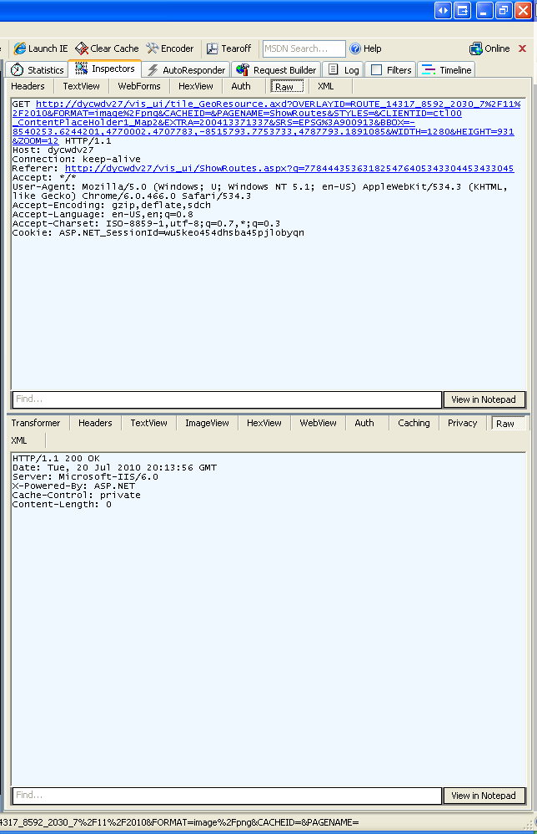

Using Fiddler to check the RawXML for Working request –
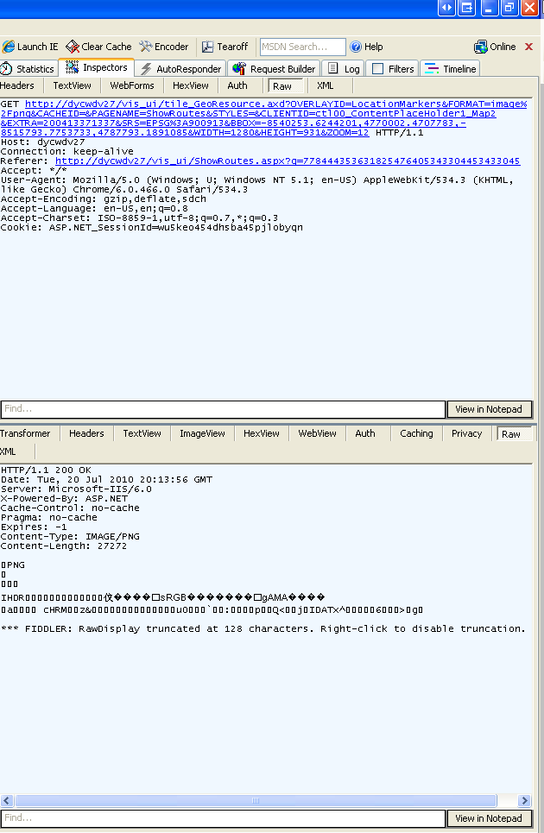

Code to add Stops information –
TextStyle textStyle = TextStyles.City1(ConstantsHelper.LABEL_KEY_NAME);
mapShape.ZoomLevelSet.ZoomLevel01.DefaultTextStyle = textStyle;
mapShape.ZoomLevelSet.ZoomLevel01.DefaultPointStyle.PointType = PointType.Bitmap;
mapShape.ZoomLevelSet.ZoomLevel01.DefaultPointStyle.Image = new GeoImage(iconName);
textStyle.PointPlacement = PointPlacement.Center;
textStyle.YOffsetInPixel = 0;
textStyle.MaskMargin = 2;
textStyle.DuplicateRule = LabelDuplicateRule.UnlimitedDuplicateLabels;
textStyle.OverlappingRule = LabelOverlappingRule.AllowOverlapping;
textStyle.TextLineSegmentRatio = 1000;
textStyle.SuppressPartialLabels = false;
textStyle.Font = new GeoFont(ConstantsHelper.CUSTOM_LABEL_FONT_NAME,
ConstantsHelper.CUSTOM_LABEL_FONT_SIZE, DrawingFontStyles.Bold);

mapShape.ZoomLevelSet.ZoomLevel01.ApplyUntilZoomLevel = ApplyUntilZoomLevel.Level20;
_shapeLayer.MapShapes.Add(mapFeature.Id, mapShape);

Code to Add Route information –

TextStyle textStyle = TextStyles.City1(ConstantsHelper.LABEL_KEY_NAME);
LineStyle lineStyle = mapShape.ZoomLevelSet.ZoomLevel01.DefaultLineStyle;
mapShape.ZoomLevelSet.ZoomLevel01.DefaultTextStyle = textStyle;

textStyle.Mask = new AreaStyle(new GeoPen(GeoColor.StandardColors.Black, 1),
new GeoSolidBrush(GeoColor.StandardColors.BlanchedAlmond));
textStyle.MaskMargin = 2;
textStyle.HaloPen = new GeoPen(GeoColor.GeographicColors.Ice, 2);
textStyle.DuplicateRule = LabelDuplicateRule.UnlimitedDuplicateLabels;
textStyle.OverlappingRule = LabelOverlappingRule.AllowOverlapping;
textStyle.TextLineSegmentRatio = 1000;
textStyle.SuppressPartialLabels = false;

lineStyle.OuterPen = new GeoPen(routeColor, ConstantsHelper.DEFAULT_ROUTE_WIDTH_PIXELS);
lineStyle.CenterPen.DashStyle = lineStyle.InnerPen.DashStyle = lineStyle.OuterPen.DashStyle = lineDashStyle;

mapShape.ZoomLevelSet.ZoomLevel01.ApplyUntilZoomLevel = ApplyUntilZoomLevel.Level20;
_shapeLayer.MapShapes.Add(mapShape.Feature.Id, mapShape);

