This is after opening the layers. I used the purple triangles to display the CurrentExtent:

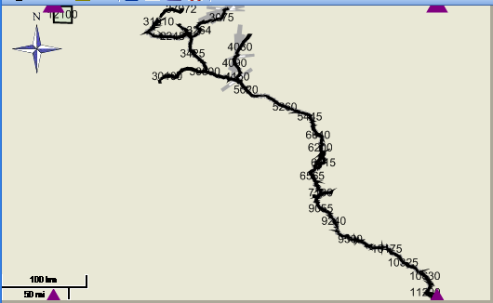

The red dot is the point i want to use to center.

After displaying the train layer. The CurrentExtent is still nicely placed in the map:

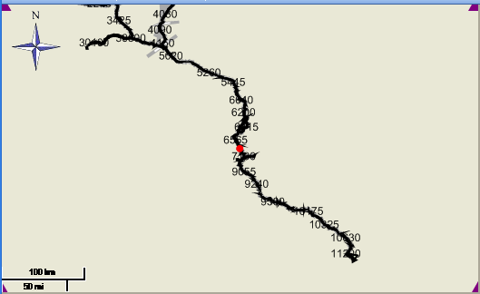

After a few iterations:

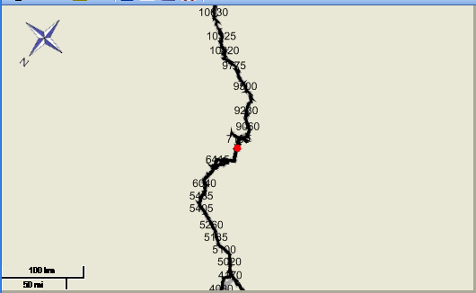

I can only see the CurrentExtent after I zoomed in:

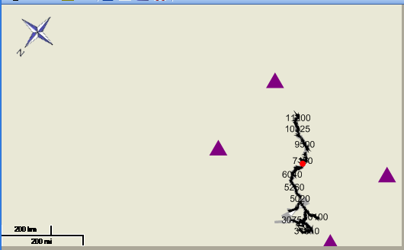

After more iterations, the red point moves off the map:

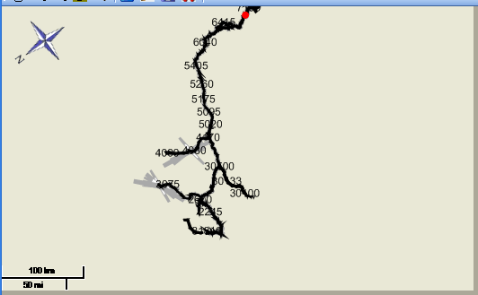

When i zoom in, the point is not even centered in the CurrentExtent anymore:

